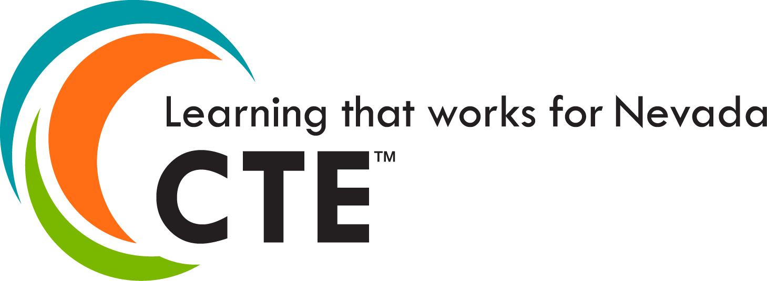
Chapter Success Guide 2023 – 2024
TABLE OF CONTENTS
HOSA OVERVIEW 4
History, Size and Reach of HOSA 4
HOSA Endorsements 4
HOSA is Co-curricular 4
HOSA Facts 5
KEY CONTACT INFORMATION 6
KEY EVENTS AND DATES 9
Nevada HOSA Advisor Academies 9
Fall Leadership Experience (All CTSOs) 9
Nevada HOSA Health Careers Leadership Experience 10
Regional Online Testing 10
SLC Online Testing 10
State Leadership Conference (SLC) 10
International Leadership Conference (ILC) 11
YEARLY CALENDAR 12
MEMBERSHIP INFORMATION 14
Affiliation Requirements 14
Initial Affiliation Application 15
Affiliation and Curriculum Fees & Payments 15
Chapter Officer List & Program of Work 16
National HOSA Chapter Membership Recognition 18
Nevada HOSA Health Science 100% Membership Recognition 18
Nevada HOSA Membership Recognition 18
Nevada HOSA Chapter of the Year 19
STARTING A CHAPTER 20
Affiliation Process 20
COMPETITIVE EVENTS PROGRAM 21
HOSA’s Competitive Events Program 21
How to Prepare for a Competitive Event 21
Competitive Event Changes and Updates for 2022-2023 23
Event Topics for 2022-2023 25
ONLINE TESTING 27
RECOGNITION EVENTS 29
Healthcare Issues Exam 29
National Service Project (HOSA Service Project) 29
Barbara James Service Award 30
HOSA Happenings 30
Outstanding HOSA Achievement 30
INTERNATIONAL LEADERSHIP CONFERENCE 31
Welcome to Texas! 31
Eligibility 31
ILC Registration Process 31
STATE OFFICER GOALS AND INITIATIVES 33
Communication 33
Membership 33
Advocacy 33
Participation 34
Conferences 34
STATE PROGRAMS AND OPPORTUNITIES 35
Chapter Visits 35
Nevada HOSA Online Newsletter 35
Nevada HOSA Social Media 35
State Pin Design Contest 36
NATIONAL PROGRAMS AND OPPORTUNITIES 37
Washington Leadership Academy 37
HOSA E-Magazine 38
National Service Project 38
RUNNING FOR OFFICE 39
Become a Chapter, State, or National Leader of HOSA! 39
Interested in Applying for State Office? 39
Is State Office Right for Me? 40
National Officer Selection Process 40
SCHOLARSHIPS 41
Nevada HOSA State Scholarships 41
ALUMNI 42
CONFERENCE ATTIRE 43
Official Dress Code for ALL General Sessions 43
HOSA Uniform Policy 43
Competitive Event Dress Attire 44
Other Conference Attire 44
Tips for Dress Code Success 44
HOSA BRAND 45
Meaning Behind the New Brand 45
Using the Brand 46

HOSA OVERVIEW

HOSA - Future Health Professionals is the premier organization for student leaders pursuing careers in the healthcare industry. HOSA's two-fold mission is to promote career opportunities in health care and to enhance the delivery of quality health care to all people.

History, Size and Reach of HOSA
Founded in 1976, formerly Health Occupations Students of America, HOSA - Future Health Professionals has over 260,000 members each year in nearly 5,000 middle, secondary and post secondary/collegiate chapters across the nation.

HOSA Endorsements
HOSA is endorsed by the U.S. Department of Education, Nevada Department of Education, the Health Science Education Division of the Association for Career and Technical Education, National Health Science Consortium, and over 50 other health-related partners and industry associations.

HOSA is Co-Curricular
HOSA is a national organization that operates as an integral component of the health science education curriculum. Through its network of state and local chapters, HOSA provides powerful instructional tools, recognition, leadership, networking, scholarships, and connections to the healthcare industry to thousands of members across the U.S.

Through the HOSA Competitive Events Program members compete in teams or as individuals in more than 60 different events related to all aspects of health care. HOSA integrates into the Health Science Education curriculum to develop and recognize smart, dedicated, and passionate future health professionals.

HOSA offers numerous health leadership conferences and professional development opportunities including the International Leadership Conference which will be held in Dallas, TX; Washington Leadership Academy held in Washington, D.C.; HOSA University; Fall Leadership Experience; and the Nevada State Leadership Conference.
HOSA Mission Statement
The mission of HOSA is to empower HOSA-Future Health Professionals to become leaders in the global health community through education, collaboration, and experience.

KEY CONTACT INFORMATION

NEVADA HOSA

HOSA State Charter Holder
Nevada Department of Education

Nevada HOSA Mailing Address
Nevada HOSA
P. O. Box 1440
Owasso, OK 74055

Nevada HOSA Contact Information
Phone: (888) 677-4534 | Fax: (702) 939-9058

NATIONAL HOSA HOSA

National HOSA Headquarters
548 Silicon Drive, Suite 101
Southlake, TX, 76092
Phone: (800) 321-HOSA (4672)
Fax:(972)874-0063
E-mail: hosa@hosa.org

HOSA Supply Service – Awards Unlimited
Supplies all chapter materials, member emblematic supplies and official HOSA blazer
Tim Moravec
Phone: (800) 950-3553 | Fax: (402) 474-3782
Web: https://hosastore.americommerce.com/

SOCIAL MEDIA

www.facebook.com/NevadaHOSA
www.facebook.com/hosafhp
https://twitter.com/nevadahosa
https://www.instagram.com/nevadahosa

WEBSITES

Nevada HOSA www.nevadahosa.org
National HOSA www.hosa.org
Nevada Association for Career and Technical Education www.nacteonline.org
NDE Office of Career, Technical & Adult Education https://doe.nv.gov/CTE/

STATE MANAGEMENT TEAM

Daphne Dale, RN, BSN | Executive Director
Governance, Industry Partnerships, Operations, State Officer Team
Email executivedirector@nevadahosa.org

Heather Watterlond, LPN, BHA | State Director
Conferences and Events, Membership
Email hq@nevadahosa.org

Jane Shovlin, RN, BSN | Chapter Support and Development
Chapter Support and New Chapter Development
Email jane@nevadahosa.org
Emily Carter | State Officer Coach
Executive Leadership Program
Email coach@nevadahosa.org

Ryan Underwood | Senior Director
Advocacy/Public Relations, Board Support
Email ryan@nevadahosa.org

Luetta Mann | Competition Manager
Competitive Events
Email luetta@nevadahosa.org

BOARD OF TRUSTEES

Randi Hunewill | Board Chair
hunewillrandi@gmail.com

Braiden Green | Vice Board Chair
College of Southern Nevada

Frank Sakelarios | Board Member Secretary/Treasurer
Carson High School

Edward (Ted) Milano | Board Member

James Todd Hamburg | Board Member
Northwest Career & Technical Academy

Damon Schilling | Board Member
American Medical Response

Andrea Gregg | Board Member
High Sierra AHEC

Ovidia McGuiness | Board Member
Sierra Specialty Pharmacy

Rae Elaine Dungao | Board Member
Clark County School District - CTE Instructor

Melina Nguyen| State President

Vacant | State Secretary

Lee Roberts | Ex-Officio
VP of Health Science & Public Safety, NACTE
roberal@nv.ccsd.net

Jennifer Fisk | Ex-Officio
CTSO Liaison – HOSA, Nevada Department of Education
jennifer.fisk@doe.nv.gov

Daphne Dale, RN BSN | Ex-Officio
Executive Director, Nevada HOSA
executivedirector@nevadahosa.org

STATE OFFICER TEAM

Melina Nguyen | State President
West Career & Tech Academy
president@nevadahosa.org

Anushka Madhira | Northern Region VP
Coral Academy of Science High School
northernvp@nevadahosa.org

Lily Kazemi | Southern Region VP
West Career & Tech Academy
southernvp@nevadahosa.org

Arlene LeBlanc | Western Region VP
Carson High School
westernvp@nevadahosa.org

Josephine Shaw | Postsecondary VP
University of Nevada Las Vegas
postsecvp@nevadahosa.org
Zachary Pearl| State Secretary
Rancho High School
secretary@nevadahosa.org

KEY EVENTS AND DATES

Nevada HOSA Advisor Conferences
Registration Fee: Complimentary
Register online at https://nevadahosa.org/advisor-conferences
Don’t miss out on the exciting Advisor Conference with training and content specifically for HOSA advisors and prospective advisors. Speakers and presenters will help you make the most of the HOSA program.
Reno
September 7, 2023
Nugget Casino and Resort, Sparks, NV
Las Vegas
September 9, 2023
Thomas & Mack Center, UNLV, Las Vegas

Fall Leadership Experience (All CTSOs)
Registration Deadline: More information will be coming soon!
Information available at https://nevadahosa.org/flex
The Leadership Rally is designed for general chapter members and leaders, with a keynote speaker and training sessions on personal excellence, HOSA involvement, leadership training and more!
Nevada CTSO Fall Leadership Experience
Elko - October 10, 2023
Time: 8:30am-1:15pm
Location: Great Basin College
Registration Fee: $30.00 per person
Lunch is not included. Chapters will be responsible for providing their own lunch.
Reno - October 11, 2023
Time: 8:30am-1:15pm
Location: National Auto Museum
Registration Fee: $30.00 per person
Lunch is not included. Chapters will be responsible for providing their own lunch.
Las Vegas - October 12, 2023
Time: 8:30am-1:15pm
Location: Red Rock Resort & Casino
Registration Fee: $30.00 per person
Lunch is not included. Chapters will be responsible for providing their own lunch.

Nevada HOSA Health Careers Leadership Experience
Registration Deadline: More information will be coming soon!
Information available at www.nevadahosa.org
The Health Careers Leadership Experience is designed for general chapter members and leaders, with a keynote speaker and training sessions about a future in a health career field.

Nevada HOSA Health Careers Leadership Experience
TBD, 2023

Regional Online Testing
Registration Fee: $8 per test
Registration Window: October 30 – November 17, 2023
Online Testing Window: November 27 – December 15, 2023
Online tests determine which competitive event members will participate in. All members must have paid their affiliation fees prior to registering for Regional Online Testing.
*Event is optional

SLC Online Testing Add Testing online for skills events
Registration Fee: $8 per test
Registration Window: December 18, 2023 - January 5, 2024
Online Testing Window: January 8 - January 19, 2024
Online tests determine who advances to compete at the State Leadership Conference in the events that require a Round 1 score. Online tests also determine finalists and winners for events that only require a test. All members must have paid their affiliation fees prior to registering for SLC Online Testing.

State Leadership Conference (SLC)
Registration Fee: $150 per attendee
Conference Registration Window: January 22 – February 2, 2024
The pinnacle of Nevada HOSA is the State Leadership Conference. Students from all over Nevada come to compete for an opportunity to advance to the International Leadership Conference. Aside from competition, this conference includes many networking opportunities, leadership sessions, and a chance to create lasting friendships among chapter members. All members must have paid their affiliation fees prior to registering for the conference.

Reno, Nevada
February 26 - 28, 2024
The Nugget Hotel | Sparks, NV

International Leadership Conference (ILC)
Registration information will be available at www.nevadahosa.org
Registration Fee: $150 per attendee
The HOSA International Leadership Conference (ILC) is the highlight of the HOSA year. Over 12,000 middle school, high school, and postsecondary/collegiate students, advisors, industry leaders, and alumni gather for several days of HOSA excitement. Most participants at ILC compete in one of HOSA’s competitive events, and the top competitors in each event are recognized for their outstanding achievements. In addition to the competitive events, many students and advisors participate in HOSA International Leadership University and the Education Symposiums.

Houston, TX
June 26 – 29, 2024
George R. Brown Convention Center | Houston, TX

2023-2024 YEARLY CALENDAR

Date | Activity |  | Location/Notes
September 7, 9 | Advisor Conference |  | Reno, Las Vegas
September  23 – 26 | Washington Leadership Academy  Training program for state officers |  | Grand Hyatt Washington  Washington, D.C.
September  26 – 29 | State Advisor’s Management Conference  State Management Team attends |  | Grand Hyatt Washington  Washington, D.C.
October 10,11,12 | Fall CTSO FLEX Conference |  | Elko, Reno, Las Vegas
October 15 | Initial Affiliation Deadline for HOSA 100 Club Recognition  Initial Affiliation Application Deadline  Curriculum Package Fees Payment  Program of Work to Nevada HOSA |  | Mail payment to:  National HOSA  548 Silicon Drive Suite 101  Southlake, TX 76092
November TBD | Board of Trustees Meeting |  | Virtual/In Person
November 1 | State Pin Design Deadline  Design entries due by 5:00 p.m. |  | Submission guidelines available at https://nevadahosa.org/documents/
November 6-10 | HOSA Week
November 20 | 2024-2025 State Officer Applications open |  | Information will be available at www.nevadahosa.org/state officers
October 30 – November 17 | Regional Online Testing Registration Deadline |  | Registration information will be available at www.nevadahosa.org
November 27 – December 15 | Regional Online Testing Window |  | Results will be released after testing window closes
January TBD | SLC State Officer Planning Meeting  State officers only |  | Nugget Casino Resort  Reno, NV
January 13 | Curriculum Fees Deadline to be eligible for Online Testing  Online testing for Health Science events only |  | Affiliation Instructions available at www.nevadahosa.org/affiliation  Mail payment to:  National HOSA  548 Silicon Drive Suite 101  Southlake, TX 76092
January 2 – 13 | Online Testing Registration Window  Online testing for Health Science events only  Members must have paid curriculum fees to register |  | Registration Packet  will be available at www.nevadahosa.org
January 16 – 27 | Online Testing Open  Online testing for Health Science events only  Members must have paid curriculum fees to test |  | Instructions will be provided to registered chapters
January 30 | Online Testing Results Announced |  | Results will be emailed to advisors and posted at www.nevadahosa.org
Date |  | Activity |  | Location/Notes
January 26 |  | State Officer Application Due |  | State Officer Candidate Packet and Application will be available at https://nevadahosa.org/state-officers/
January 30 - February 10 |  | State Leadership Conference  Registration Window  Attendees must submit curriculum fees to participate |  | Registration Packet  will be available at www.nevadahosa.org
February 1 |  | All NV HOSA Recognition Events, Awards, Scholarship application DUE |  | Complete Form on www.nvhosa.org
February 10 |  | Curriculum Fees Deadline  to be eligible to compete  Must submit curriculum fees by this deadline to be eligible to compete at SLC |  | Affiliation Instructions available at www.nevadahosa.org/affiliation  Mail payment to:  National HOSA  548 Silicon Drive Suite 101  Southlake, TX 76092
February 10 |  | National Officer Candidate Applications due to Nevada HOSA |  | National Officer Candidate Packet and Application will be available from State Advisor via email
February 24, 2024 |  | Nevada HOSA, Inc. Board of Trustees Meeting |  | Nugget Hotel  Reno, NV
February 26-28, 2024 |  | State Leadership Conference  -HOSA’s Competitive Events Program  -State officer Nominating Committee and election process  -Health symposiums and leadership development |  | Nugget Hotel  Reno, NV
April TBD |  | National HOSA Scholarship Deadline  -Visit national web site for scholarship guidelines |  | For more information, visit www.hosa.org
April 7 |  | International Leadership Conference Intent to Compete Deadline |  | National Leadership Conference Packet will be available at www.nevadahosa.org
April 10 |  | International Leadership Conference Competitor Notification by Nevada HOSA |  | For more information, contact statedirector@nevadahosa.org
May 10 |  | International Leadership Conference Registration Deadline |  | National Leadership Conference Packet will be available at www.nevadahosa.org
June TBD |  | Nevada HOSA, Inc. Board of Trustees Meeting |  | TBD
June 21 – 24 |  | International Leadership Conference  - HOSA’s Competitive Events Program  - HOSA National Leadership University  - Educational Symposiums  - National Executive Council Elections |  | Houston, TX
MEMBERSHIP INFORMATION

Affiliate early and achieve HOSA 100 Club Recognition. Nevada HOSA Chapters are encouraged to affiliate early in the year to achieve HOSA 100 Club recognition. To achieve HOSA 100 Club Recognition, Nevada HOSA chapters should meet the requirements listed above by October 15.

Affiliation Benefits. All Nevada HOSA chapters completing the Affiliation process will acquire access to Nevada HOSA Curriculum Online, an exclusive area on the website which provides Health Science Instructional Supplement Resources, tools, and information to be utilized through HOSA and in the classroom. Chapters who complete the Initial Affiliation Process will receive a password to a secure area on the Nevada HOSA Website.

All chapters achieving HOSA 100 Club affiliation status will receive a certificate and be recognized in HOSA online publications.

Affiliation Requirements
To be an officially recognized Nevada HOSA chapter, the following requirements should be met:
https://nevadahosa.org/chapter-registration/

Submit Annual Chapter Registration Form
Complete registration form through Nevada HOSA. Once received, you will receive a chapter number and then set up your password.
Must have 5 members and 1 advisor

Submit all curriculum fees (National HOSA dues and Nevada HOSA curriculum fees):
Send payment to: National HOSA
548 Silicon Drive, Suite 101
Southlake, TX 76092
Include your school’s name and chapter number.

Initial Affiliation Application
The Affiliation Process is online, and it is easy!
- Go to the National HOSA website: https://apps.hosa.org/
- You will then be asked for your national charter number (“Login”) and password. Enter the information and begin the online affiliation process.
- After successfully logging in, click on the “+” sign to enter members into the HOSA online system.

TIP: REVIEW THE ONLINE AFFILIATION INSTRUCTIONS
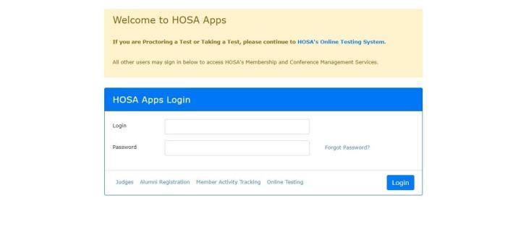
To access instructions for online affiliation, please click on the first link in the main menu. It is recommended that you review the instructions if you are unfamiliar with the online affiliation system.

Affiliation and Curriculum Fees & Payments
Once local members are entered into the affiliation system, the chapter is ready to submit payment.

Fees. The National HOSA affiliation fee is $10.00 per member. The Nevada HOSA curriculum fee is $12.00 per member until October 15. Fees total $22.00 per member.

Submit payment. To make payment, follow the following steps:

- Print Invoice. To access the invoice, go to the Main Menu of the National HOSA Affiliation System. Select Account Statement on the main page.
- Make checks payable to National HOSA. Both national affiliation fees and state curriculum fees are submitted and paid to National HOSA.
- Mail payment and copy of invoice to: National HOSA
548 Silicon Drive, Suite 101
Southlake, TX 76092

National HOSA Chapter Membership Recognition
HOSA 100 Club: Chapters that submit their paid affiliation fees by October 15 will be recognized as members of the HOSA 100 Club and will be listed in the HOSA Spring E-Magazine.

HOSA 100% Affiliation Club: Chapters that affiliate 100% of their Health Science students with HOSA will be recognized as a member of the HOSA 100% Affiliation Club and will be listed on the HOSA web site.

Nevada HOSA Health Science 100% Membership Recognition
Deadline: October 15
The Health Science 100% Membership award recognizes school health science programs for affiliating with HOSA. Earn prime seating at the State Leadership Conference! Increase the percentage of health science student membership in your HOSA chapter to receive special recognition. This award will be calculated using the SAIN Database.

- Gold Level – 100% of health science students are HOSA members.
- Silver Level – 50% of health science students are HOSA members.
- Bronze Level – 5% of health science students are HOSA members.

To apply for Health Science 100% Membership Recognition, visit: https://nevadahosa.org/health-science-100-membership-recognition/

Nevada HOSA Membership Recognition
Deadline: Recognition will be based on paid membership as of February 10
Nevada HOSA will celebrate the recruitment efforts of chapters during the State Leadership Conference.

Nevada HOSA Chapter of the Year
Deadline: January 30
The Chapter of the Year program recognizes the top chapters in the state. Chapters earn points for participating in the many activities offered by Nevada HOSA in the areas of chapter management, conference attendance and recognition, recruitment, public relations, and participation in state and national projects. Activities will be based on participation and involvement, not just the size of the chapter. Points will be awarded based on the criteria below. The top three chapters will be recognized at the State Leadership Conference.

Chapter Management
- Complete Chapter Registration Application and Payment (By October 15 = Bonus points)
- Complete and submit Program of Work
- Meet with a state officer or Nevada HOSA representative (Chapter Visits, Phone Calls, Google+ Hangouts, etc.)
- Increase chapter membership
- Submit an article about your chapter or a chapter event to Nevada HOSA for the Online Newsletter
- Other activities to strengthen the HOSA chapter

Conferences and Events
- Representation at Advisor Academy
- Participation in Nevada HOSA State Pin Design Contest
- Representation at Nevada CTSO Leadership Rally
- Participation at Presidents Council Meetings
- Representation on Advisor Webinars/Huddles
- Participation at the State Leadership Conference
- Other HOSA related conference and events

Community Outreach
- Raise funds for National Service Project – Be the Match
- Partner with the Medical Reserve Corp at the local level
- Promote HOSA during HOSA Week

To apply for Chapter of the Year, visit: https://nevadahosa.org/nevada-hosa-coy/

STARTING A CHAPTER

Over 2,300 members in nearly 40 chapters across Nevada have made the decision to join HOSA and become Future Health Professionals! How can you start a HOSA chapter at your school?

Requirements. To start a HOSA chapter, identify a faculty member to serve as the chapter advisor and recruit at least five members interested in pursuing careers in health care.

Affiliation Process
Get started today! Just follow these steps:
- Contact Nevada HOSA Chapter Support at 520-820-5840 or Hello@nevadahosa.org and indicate your interest in starting a HOSA chapter!
- Decide which method your program will use to organize one or more HOSA chapters. The options are:
  - Classroom-based chapter. A HOSA chapter is formed for each health science class of five (5) or more students.
  - Instructor-based chapter. A chapter is formed by one health science instructor for all students enrolled in his/her classes.
  - School-based chapter. A single chapter is formed for all students in all classes regardless of the number of teachers.
- Contact local school/college officials (e.g., activity directors, Dean of Student Activities) and inform them about starting a HOSA chapter. There may be additional rules, regulations, or approval processes to fulfill in order to start a HOSA Chapter. This is also a great opportunity to educate school officials about the benefits of HOSA.
- Complete the Online Chapter Affiliation Application.
- Elect chapter officers and develop a Program of Work.
- Set up a school visit by the state officers to help guide your chapter into the world of HOSA!

COMPETITIVE EVENTS PROGRAM

HOSA’s Competitive Events Program provides members the opportunity to showcase their skills, knowledge, and leadership abilities in 38 different healthcare-related events and recognition events. The Competitive Events Program recognizes members for their excellence in competition on the state and national level. The top state performers qualify to compete at HOSA’s annual International Leadership Conference. For more information on Competitive Events, utilize the resource page at https://nevadahosa.org/documents/ and on the National HOSA page https://hosa.org/competition/

Please Note:
The following competitive events are not offered in Nevada. **Clinical Nursing, Clinical Specialty, Creative Problem Solving, , Prepared Speaking, Parliamentary Procedure**

New Events that are eligible for competition at 2024 SLC:
Foundations of Veterinary Science for Middle School; Home Health Aide; Researched Persuasive Writing and Speaking.

- Competitive event guidelines are in the HOSA Handbook, Section B at
http://www.hosa.org/GRR.

Event Topics for 2023-2024
2023 – 2024 National HOSA Theme:
“DARE TO CREATE”

National Service Project

2022-2024 Service Organization: Be the Match
https://bethematch.org/

ONLINE TESTING

All testing for the State Leadership Conference occurs on-site except the Health Science categories. The Health Science events offered to Nevada HOSA members are administered through HOSA’s online testing system and include:

Testing Fee. Each Health Science test a student takes is $8. Nevada HOSA will bill each chapter after registration has closed. Any student who signs up to take a test will be charged the $8 fee, regardless of whether or not they complete the test.

Dates. Mark your calendars with these important Online Testing related dates and deadlines.

January 13, 2023
Deadline for Member Affiliation & Curriculum Fees to be eligible for Online Competitions

January 2 – 13, 2023
Online Testing Registration Window

January 16 – 27, 2023
Online Testing Window

Registration. Students who are planning to compete in a Health Science Category event (listed above) must take the test online. Advisors should log into the National HOSA affiliation system (https://apps.hosa.org/) using their unique login and password and scroll to “Conferences.” From there choose “NV SLC On-Line Testing'' from the list of conferences. You can follow the on-screen instructions to register your members for their respective health science events.

RECOGNITION EVENTS

HOSA’s Recognition Events are designed to recognize members and chapters for outstanding work in HOSA and HOSA-related projects. There are six Recognition Events that students are able to choose from, with recognition on both the state and national level.

Although students can only compete in one competitive event at the state and national conference, they can participate in as many recognition events as they wish.

The Recognition Events are:
- Health Care Issues Exam
- National Service Project (HOSA Service Project)
- Barbara James Service Award
- HOSA Happenings
- Outstanding HOSA Achievement

Complete rules and guidelines, criteria, applications, and verification forms are available on our website at http://nevadahosa.org/recognition.

INTERNATIONAL LEADERSHIP CONFERENCE

The Annual International Leadership Conference (ILC) brings together thousands of future health professionals from across the country! This conference features:
- Exciting general sessions
- Educational and social learning activities
- Leadership academies
- Tours to healthcare facilities
- Exhibits presented by professional healthcare associations
- National Competitive Events
- Annual business of the national student organization of HOSA, including the election of national leaders
- Educational symposiums
- Fun, excitement, recognition, and opportunities for HOSA members!

Welcome to Texas!
This year’s International Leadership Conference will be held June 26-29 at the George R. Brown Convention Center Houston, TX. For more information, visit https://hosa.org/ilc/.

Eligibility
All members registered by the Nevada HOSA ILC deadline are eligible to attend ILC.

For competitive events, Nevada HOSA sends the top three competitors/teams in each event to compete at ILC. To be eligible to compete, chapters must complete every step in the Registration Process including the Intent to Compete Form and Online Conference Registration.

ILC Registration Process
Each year, Nevada HOSA will publish an ILC Registration Guide, which serves as your guide in preparation for ILC. Although National HOSA provides registration information and deadlines, it is important to adhere to Nevada HOSA’s process in order to be eligible to attend.

State Winners List: Following the State Leadership Conference, Nevada HOSA publishes the list of winners. The top three individuals or teams in each event are eligible to compete at Internationals. However, if a competitor decides not to attend ILC, Nevada HOSA will move up to the next competitor. This means that members placing 4th or 5th could still have an opportunity to compete at nationals.

Intent to Compete: All top five winners in all competitive events must submit an Intent to Compete form. This form serves as official notification to Nevada HOSA regarding a competitor’s

Every competitor who received 1st, 2nd, 3rd, 4th, or 5th place should have an Intent to Compete form completed, even if the competitor(s) will not attend ILC. Any forms not received by the Intent to Compete deadline will be assumed as “No, will not attend” response.
Intent to Compete Deadline: April 5, 2024
ILC Competitor Notification: All Intent to Compete Forms will be processed, and chapters notified with a final ILC Competitor List. This list will be published on the Nevada HOSA website at www.nevadahosa.org.
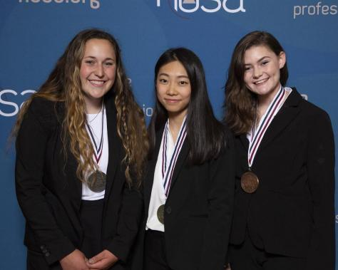
ILC Competitor Notification Release Date: April 10, 2024

ILC Online Registration: The Nevada HOSA ILC Registration Guide will provide the steps to register for the conference. Although National HOSA provides registration information and deadlines, it is important to adhere to Nevada HOSA’s process. Chapters are responsible for registering students for events and confirming chapter details. Registration must be completed by the Nevada HOSA deadline as a validation process takes place immediately after the deadline.
ILC 2019 Extemporaneous Writing Winners (Right: Rachel Weese, Nevada Bronze Medalist)
ILC Registration Payment: Registration payments should be directed to Nevada HOSA. Please make checks payable to Nevada HOSA and mail check to:
Nevada HOSA
P. O. Box 1440
Owasso, OK 74055

TIP: IT’S NEVER TOO EARLY!
It’s never too early to start planning for the International Leadership Conference! Start planning ahead by saving the dates in the calendar, studying competitive event guidelines, and fundraising.

STATE PROGRAMS AND OPPORTUNITIES

Chapter Visits
Having a state officer visit a local chapter connects state officers with local members while giving the state officers an opportunity to promote state and national conferences, programs, and initiatives. State officers can discuss a particular event, explain HOSA to a new chapter, and encourage students to get involved. Oftentimes chapters can connect with a state officer’s passion, excitement, and commitment to HOSA and use it to foster those same feelings in their chapter. To schedule a visit, go to this link: https://nevadahosa.org/request-a-chapter-visit/

Nevada HOSA Weekly Update
Check your email for the NVHOSA Weekly Update - If you are not receiving it, please contact hello@nevadahosa.org

Nevada HOSA Social Media
Nevada HOSA is on Twitter (www.twitter.com/nevadahosa) where we regularly post quick updates and announcements about events, activities, programs, health related news and announcements, and key accomplishments. Visit us on Twitter and sign up to follow Nevada HOSA to stay up to date on what’s new and happening with Nevada’s Future Health Professionals!

Follow us! @NevadaHOSA
Nevada HOSA is on Facebook (www.facebook.com/NevadaHOSA) where we post more detailed updates, pictures, and videos that allow us to report on key accomplishments, events, activities, chapter accomplishments, and more. The Nevada HOSA State Officer Team uses Facebook to stay in touch with members, advisors, alumni, and supporters. Members are also able to leave comments, share information, and more. Visit us on Facebook and like Nevada HOSA!

WEBSITES

Nevada HOSA www.nevadahosa.org
National HOSA www.hosa.org
Nevada Association for Career and Technical Education www.nacteonline.org
NDE Office of Career, Technical & Adult Education https://doe.nv.gov/CTE/

State Pin Design Contest

Every year Nevada HOSA creates a state pin used as the State Leadership Conference pin and as the official trading pin for the state during the International Leadership Conference. Members are encouraged to create a pin design that captures Nevada, the state/national theme, and/or the ILC destination. Voting will take place at the Leadership Experience and the winning pin design will be used as the inspiration for the official trading pin of Nevada. Click the link below for more information.

https://nevadahosa.org/documents/

Questions? Please contact: hello@nevadahosa.org | (888) 677-4534

2023 – 2024 Nevada HOSA Theme:
“Dare to Create”

NATIONAL PROGRAMS AND OPPORTUNITIES

Washington Leadership Academy
The Washington Leadership Academy in Washington, D.C., has been hosted annually by HOSA for State Officers, and Local Chapter Leaders. It is a training experience for future HOSA leaders who are interested in learning more about running for local chapter office, becoming a more effective leader, understanding and valuing people, interacting with others, and serving the organization and others. This action-packed experience provides the highest level of HOSA leadership training available. We encourage local chapter leaders and members who want to strengthen their leadership skills and build their resume to join HOSA in Washington, D.C. There are also opportunities for local chapter advisors to interact and share valuable ideas with other HOSA advisors. The Washington Leadership Academy will be hosted September 23-26, 2023. For more information, visit www.hosa.org.

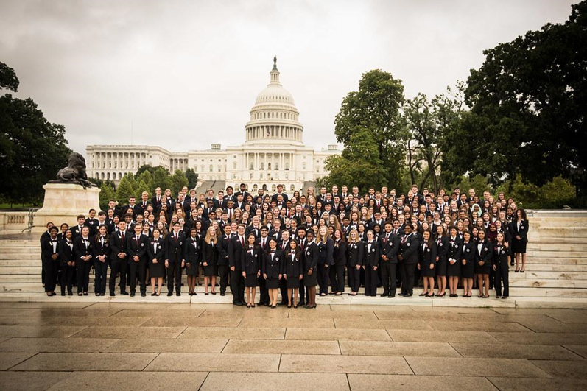

HOSA E-Magazine

The HOSA E-Magazine is the official publication of National HOSA for its members, advisors, partners, and supporters. The E-Magazine includes articles and information on chapter spotlights, alumni success stories, HOSA partners, healthcare related news, HOSA conferences, events and opportunities, and more! Many of the articles are written by individual members and every chapter is encouraged to write and submit an article. The E-Magazine is published three times a year and articles can be sent to hosa@hosa.org at any time for inclusion in the next issue. Visit www.hosa.org and select “E-Magazine” on the left menu bar to view the latest E-Magazine!

SCHOLARSHIPS
HOSA’s inter-curricular program fosters a culture of learning, discovery, and hard work. HOSA members look to prepare for their futures, and many continue their education into the postsecondary/collegiate level. HOSA’s scholarship program is designed to support members’ pursuit of a higher education and reward outstanding members with scholarships. Visit the website below for further information.

https://hosa.org/scholarships/

ALUMNI

Any supporters of HOSA are encouraged to become Alumni members!

How to become an alumni member:
- Complimentary alumni membership is available at both the state and national level. It’s free!!!
- Go to https://apps.hosa.org/#alumni-registration and apply for Alumni Membership
- Complete the application and submit to National HOSA. That’s all you need to do!
- Registration is one time only; you don’t have to do it again!

