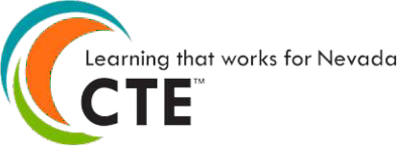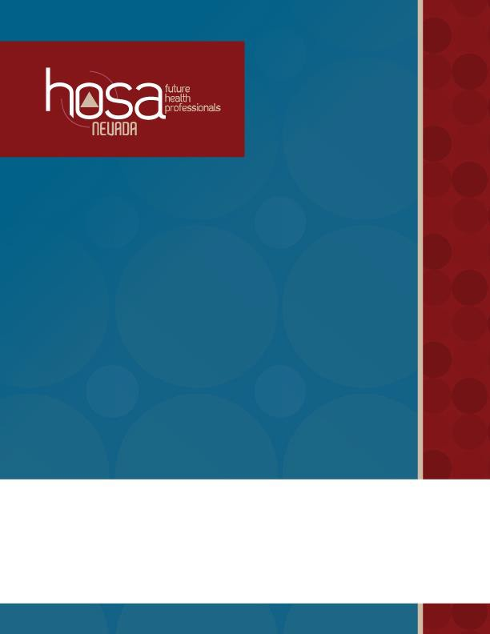

**2024-2025 Chapter**

**HOSA**

### CHAPTER SUCCESS GUIDE

2024 - 2025

## HOSA OVERVIEW

HOSA - Future Health Professionals is the premier organization for student leaders pursuing careers in the healthcare industry. HOSA's two-fold mission is to promote career opportunities in health care and to enhance the delivery of quality health care to all people.

**History, Size and Reach of HOSA**

Founded in 1976, formerly Health Occupations Students of America, HOSA - Future Health Professionals has over 260,000 members each year in nearly 5,000 middle, secondary and post secondary/collegiate chapters across the nation.

**HOSA Endorsements**

HOSA is endorsed by the U.S. Department of Education, Nevada Department of Education, the Health Science Education Division of the Association for Career and Technical Education, National Health Science Consortium, and over 50 other health-related partners and industry associations.

**HOSA is Co-Curricular**

HOSA is a national organization that operates as an integral component of the health science education curriculum. Through its network of state and local chapters, HOSA provides powerful instructional tools, recognition, leadership, networking, scholarships, and connections to the healthcare industry to thousands of members across the U.S.

Through the HOSA Competitive Events Program members compete in teams or as individuals in more than 60 different events related to all aspects of health care. HOSA integrates into the Health Science Education curriculum to develop and recognize smart, dedicated, and passionate future health professionals.

HOSA offers numerous health leadership conferences and professional development opportunities including the International Leadership Conference which will be held in Dallas, TX; Washington Leadership Academy held in Washington, D.C.; HOSA University; Fall Leadership Experience; and the Nevada State Leadership Conference.

**HOSA Mission Statement**

The mission of HOSA is to empower HOSA-Future Health Professionals to become leaders in the global health community through education, collaboration, and experience.

Page 1

### CHAPTER SUCCESS GUIDE

2024 - 2025

# KEY CONTACT INFORMATION

###### NEVADA HOSA

**HOSA State Charter Holder**

Nevada Department of Education

**Nevada HOSA Mailing Address**

Nevada HOSA

P. O. Box 1440

Owasso, OK 74055

**Nevada HOSA Contact Information**

Phone: (888) 677-4534 | Fax: (702) 939-9058

###### NATIONAL HOSA

**National HOSA Headquarters**

548 Silicon Drive, Suite 101

Southlake, TX, 76092

Phone: (800) 321-HOSA (4672) Fax:(972)874-0063

E-mail: [hosa@hosa.org](mailto:hosa@hosa.org)

**HOSA Supply Service – Awards Unlimited**

*Supplies all chapter materials, member emblematic supplies and official HOSA blazer*

Tim Moravec

Phone: (800) 950-3553 | Fax: (402) 474-3782

Web:

<https://hosastore.americommerce.com/>

Page 2

### CHAPTER SUCCESS GUIDE

#### 2024 - 2025

###### SOCIAL MEDIA

[www.facebook.com/NevadaHOSA](http://www.facebook.com/NevadaHOSA) [www.facebook.com/hosafhp](http://www.facebook.com/hosafhp) <https://twitter.com/nevadahosa> <https://www.instagram.com/nevadahosa>

###### WEBSITES

Nevada HOSA [www.nevadahosa.org](http://www.nevadahosa.org/) National HOSA [www.hosa.org](http://www.hosa.org/)

Nevada Association for Career and Technical Education [www.nacteonline.org](http://www.nacteonline.org/) NDE Office of Career, Technical & Adult Education <https://doe.nv.gov/CTE/>

###### STATE MANAGEMENT TEAM

Daphne Dale, RN, BSN | **Executive Director**

*Governance, Industry Partnerships, Operations, State Officer Team*

Email [executivedirector@nevadahosa.org](mailto:executivedirector@nevadahosa.org)

Victoria Defilippi, MS | **State Advisor** *Conferences and Events, Membership* Email [stateadvisor@nevadahosa.org](mailto:stateadvisor@nevadahosa.org)

Jane Shovlin, RN, BSN | **NEW Chapter Support and Development**

*Chapter Support and New Chapter Development*

Email [jane@nevadahosa.org](mailto:jane@nevadahosa.org)

Victoria Defilippi, MS | **State Officer Coach**

*Executive Leadership Program*

Email [coach@nevadahosa.org](mailto:coach@nevadahosa.org)

Ryan Underwood | **Senior Director** *Advocacy/Public Relations, Board Support* Email [ryan@nevadahosa.org](mailto:ryan@nevadahosa.org)

Luetta Mann | **Competition Manager**

*Competitive Events*

Email [luetta@nevadahosa.org](mailto:luetta@nevadahosa.org)

Page 3

### CHAPTER SUCCESS GUIDE

#### 2024 - 2025

###### BOARD OF TRUSTEES

Braiden Green | **Board Chair**

Randi Hunewill | **Immediate Past Board Chair**

Lee Roberts | **Treasurer**

Tiffany Pinkerton | **Board Member** James Todd Hamburg | **Board Member** Damien Schilling | **Board Member** Melissa Osterhage | **Board Member** Andrea Gregg | **Board Member**

Ovidia L. McGuiness | **Board Member** Rae Elaine Dungao | **Board Member** Matt Mackay | **Board Member**

Frank Messina | **Board Member**

Kristina Carry | **Interim NDE CTSO Liaison**

Daphne Dale | **Executive Director** Anushka Madhira | **State President** Vanessa Rosales | **State Secretary**

###### STATE OFFICER TEAM

Anushka Madhira | **State President** Coral Academy of Science - Reno [president@nevadahosa.org](mailto:president@nevadahosa.org)

Anirudh Prabhu | **Northern Region VP** Coral Academy of Science - Reno [northernvp@nevadahosa.org](mailto:northernvp@nevadahosa.org)

G’Yanna Perry | **Southern Region VP** Advanced Technologies Academy [southernvp@nevadahosa.org](mailto:southernvp@nevadahosa.org)

Vanessa Rosales | **State Secretary** Advanced Technologies Academy [secretary@nevadahosa.org](mailto:secretary@nevadahosa.org)

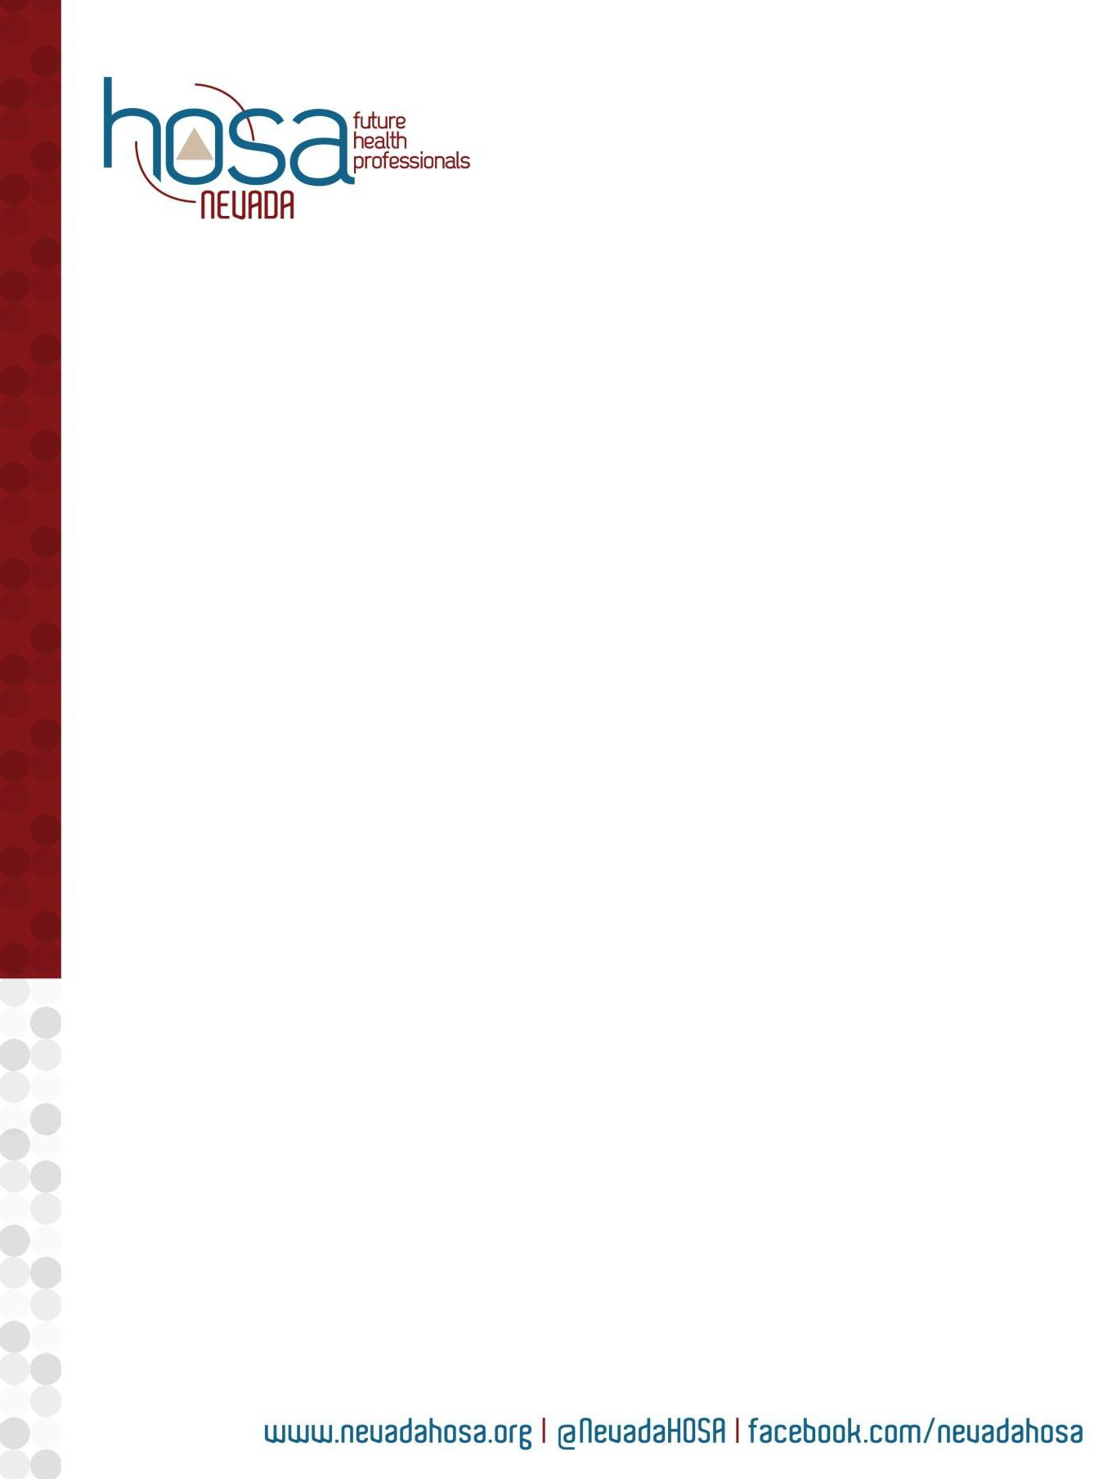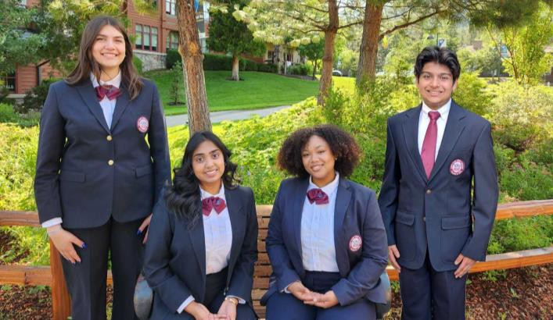

Page 4

### CHAPTER SUCCESS GUIDE



2024 - 2025

# KEY EVENTS AND DATES

Regional Online Testing

*Registration Fee:* ***$8*** *per test*

*Registration Window: October 28 – November 8, 2024*

*Online Testing Window: November 12 – November 26, 2024*

Online tests determine which competitive event members will participate in. *All members must have paid their affiliation fees prior to registering for Regional Online Testing.*

*\*Event is optional*

State Leadership Conference (SLC)

*Registration Fee:* ***$150*** *per attendee*

*Conference Registration Window: January 20– February 7, 2025*

The pinnacle of Nevada HOSA is the State Leadership Conference. Students from all over Nevada come to compete for an opportunity to advance to the International Leadership Conference. Aside from competition, this conference includes many networking opportunities, leadership sessions, and a chance to create lasting friendships among chapter members. *All members must have paid their affiliation fees prior to registering for the conference.*

**Reno, Nevada**

March 5 - 7, 2025

Grand Seirra Resort | Reno, NV

International Leadership Conference (ILC)

*Registration information will be available at* [*www.nevadahosa.org*](http://www.nevadahosa.org/)

Registration Fee: **$160** per attendee

The HOSA International Leadership Conference (ILC) is the highlight of the HOSA year. Over 12,000 middle school, high school, and postsecondary/collegiate students, advisors, industry leaders, and alumni gather for several days of HOSA excitement. Most participants at ILC compete in one of HOSA’s competitive events, and the top competitors in each event are recognized for their outstanding achievements. In addition to the competitive events, many students and advisors participate in HOSA International Leadership University and the Education Symposiums.

**Nashville, TN**

June 18 - 21, 2025

Gaylord Opryland Convention Center | Nashville, TN

To view all dates and deadlines for the 2024-2025 year, download our yearly calendar at [www.nevadahosa.org](http://www.nevadahosa.org/)

Page 5

### CHAPTER SUCCESS GUIDE

#### 2024 - 2025

Page 6



[**www.neuadahosa.org**](http://www.neuadahosa.org/)I **@neuadaHOSA** I **facebook.com/ neuadahosa**

### CHAPTER SUCCESS GUIDE

#### 2024 - 2025

Nevada HOSA YEARLY CALENDAR

|  |  |  |
| --- | --- | --- |
| **Date** | **Activity** | **Location/Notes** |
| September 27 – 30 | Washington Leadership Academy  *Training program for state officers* | Grand Hyatt Washington  Crystal Gateway Marriott Arlington, VA |
| September  28 – October 2 | State Advisor’s Management Conference  *The State Management Team attends* | Grand Hyatt Washington  Crystal Gateway Marriott Arlington, VA |
| October 15 | Initial Affiliation Deadline for HOSA 100 Club Recognition  *Initial Affiliation Application Deadline Curriculum Package Fees Payment Program of Work to Nevada HOSA* | Mail payment to: National HOSA  548 Silicon Drive Suite 101  Southlake, TX 76092 |
| November 4-8 | HOSA Week |  |
| November 8 | 2024-2025 State Officer Applications open | Information will be available at [www.nevadahosa.org/state](http://www.nevadahosa.org/state) officers |
| October 28 –  November 8 | Regional Online Testing Registration Window | Registration information will be available at [www.nevadahosa.org](http://www.nevadahosa.org/)  for $8.00 per test. |
| November 12 –  November 26 | Regional Online Testing Window | Results will be released after the testing window closes |
| December 1 | State Pin Design Deadline  *Design entries are due by 5:00 p.m.* | Submission guidelines available at [https://nevadahosa.org/documents](https://nevadahosa.org/documents/)  [/](https://nevadahosa.org/documents/) |
| January TBD | SLC State Officer Planning Meeting  *State officers only* | Grand Sierra Resort Reno, NV |
| January 15 | Curriculum Fees Deadline to be Eligible for Online Testing  *Online testing for ALL tests*  *Students must have paid curriculum fees to test* | Affiliation Instructions available at [www.nevadahosa.org/affiliation](http://www.nevadahosa.org/affiliation) Mail payment to:  National HOSA  548 Silicon Drive Suite 101  Southlake, TX 76092 |
| February 7 | State Officer Application Due | State Officer Candidate Packet and Application will be available at [https://nevadahosa.org/state-](https://nevadahosa.org/state-officers/)  [officers/](https://nevadahosa.org/state-officers/) |
| January 20-  February 7 | State Leadership Conference Registration Window  *Attendees must submit curriculum fees to participate* | Registration Packet will be available at [www.nevadahosa.org](http://www.nevadahosa.org/) |
| February 3 | *All NV HOSA Recognition Events, Awards, and Scholarship application DUE* | Complete Form on [www.nevadahosa.org](http://www.nevadahosa.org/) |
| February 10 | International Officer Candidate Applications due to Nevada HOSA | National Officer Candidate Packet  and Application will be available on the website. |
| February 12 | -Deadline for uploading all digital  upload requirements for competitive events. | -Conference Registration through your chapter |

Page 7

### CHAPTER SUCCESS GUIDE

#### 2024 - 2025

|  |  |  |
| --- | --- | --- |
|  | - Curriculum Fees Deadline to be eligible to compete  *Must submit curriculum fees by this deadline to be eligible to compete at SLC* | -Digital upload for each event is done in your chapter, and the instructions are included.  -Curriculum Fees-Mail payment to: National HOSA  548 Silicon Drive Suite 101  Southlake, TX 76092 |
| February 10 -  February 21 | Online Testing Open  *Members must have paid curriculum fees to test* | Instructions will be provided to registered chapters |
| March 4 | Nevada HOSA, Inc. Board of Trustees Meeting | Grand Sierra Resort Reno, NV |
| March 5 – March 7  March 4 is Early check-in and Registration | State Leadership Conference  *-HOSA’s Competitive Events Program*  *-State officer Nominating Committee and election process*  *-Health symposiums and leadership development*  March 4 is early check-in and registration | Grand Sierra Resort Reno, NV |
| March 19 | International Leadership Conference Intent to Compete Deadline  *-Every competitor within the top 5 must complete this form* | The International Leadership Conference Packet will be available at [www.nevadahosa.org](http://www.nevadahosa.org/) |
| March 26 | International Leadership Conference Competitor Notification by Nevada HOSA | For more information, contact [stateadvisor@nevadahosa.org](mailto:stateadvisor@nevadahosa.org) |
| April 15 | National HOSA Scholarship Deadline | [www.hosa.org](http://www.hosa.org/)  *-Visit the national website for scholarship guidelines* |
| May 12 | International Leadership Conference Registration Deadline for Nevada  *-If completed after this deadline, NV HOSA Staff will not be able to assist with*  *registration* | National Leadership Conference Packet will be available at [www.nevadahosa.org](http://www.nevadahosa.org/) |
| June TBD | Nevada HOSA, Inc. Board of Trustees Meeting | TBD |
| June 18-21 | International Leadership Conference   * *HOSA’s Competitive Events Program* * *HOSA National Leadership University* * *Educational Symposiums* * *National Executive Council Elections* | Gaylord Opryland Convention Center, Nashville, TN |

Page 8

### CHAPTER SUCCESS GUIDE

2024 - 2025

# MEMBERSHIP INFORMATION

**Affiliate early and achieve HOSA 100 Club Recognition.** Nevada HOSA Chapters are encouraged to affiliate early in the year to achieve HOSA 100 Club recognition. To achieve HOSA 100 Club Recognition, Nevada HOSA chapters should meet the requirements listed below by **October 15**.

**Affiliation Benefits.** All Nevada HOSA chapters completing the Affiliation process will acquire access to Nevada HOSA Curriculum Online, an exclusive area on the website that provides Health Science Instructional Supplement Resources, tools, and information to be utilized through HOSA and in the classroom. Chapters who complete the Initial Affiliation Process will receive a password to a secure area on the Nevada HOSA Website.

All chapters achieving HOSA 100 Club affiliation status will receive a certificate and be recognized in HOSA online publications.

Affiliation Requirements

To be an officially recognized Nevada HOSA chapter, the following requirements should be met: <https://nevadahosa.org/chapter-registration/>

**Submit the Annual Chapter Registration Form**

*Complete the registration form through Nevada HOSA. Once received, you will receive a chapter number, which you will use to set up your password.*

*Must have 5 members and 1 advisor*

**Submit all curriculum fees (National HOSA dues and Nevada HOSA curriculum fees):**

*Send payment to: National HOSA*

*548 Silicon Drive, Suite 101*

*Southlake, TX 76092*

*Include your school’s name and chapter number.*

Initial Affiliation Application

The Affiliation Process is online, and it is easy!

1. Go to the National HOSA website: <https://apps.hosa.org/>
2. You will then be asked for your national charter number (“Login”) and password. Enter the information and begin the online affiliation process.
3. After successfully logging in, click on the “+” sign to enter members into the HOSA online system.

**TIP: REVIEW THE ONLINE AFFILIATION INSTRUCTIONS**

Page 9

### CHAPTER SUCCESS GUIDE

#### 2024 - 2025

To access instructions for online affiliation, please click on the first link in the main menu. You should review the instructions if you are unfamiliar with the online affiliation system.

Affiliation and Curriculum Fees & Payments

Once local members are entered into the affiliation system, the chapter is ready to submit payment.

**Fees.** The National HOSA affiliation fee is $10.00 per member. The Nevada HOSA curriculum fee is $12.00 per member until October 15. The **total fees are $22.00 per member**.

**Submit payment.** To make payment, follow the following steps:

1. Print Invoice. To access the invoice, go to the National HOSA Affiliation System's main menu and select **Account Statement** on the main page.
2. Make checks payable to National HOSA. National affiliation and state curriculum fees are submitted and paid to National HOSA.
3. Mail payment and copy of the invoice to National HOSA

548 Silicon Drive, Suite 101

Southlake, TX 76092

National HOSA Chapter Membership Recognition

**HOSA 100 Club:** Chapters that submit their paid affiliation fees by **October 15** will be recognized as members of the HOSA 100 Club and will be listed in the HOSA Spring E-Magazine.

**HOSA 100% Affiliation Club:** Chapters that affiliate 100% of their Health Science students with HOSA will be recognized as members of the HOSA 100% Affiliation Club and listed on the HOSA website.

Nevada HOSA Health Science 100% Membership Recognition

*Deadline: October 15*

The Health Science 100% Membership award recognizes school health science programs for affiliating with HOSA. Earn prime seating at the State Leadership Conference! Increase the percentage of health science student membership in your HOSA chapter to receive special recognition. This award will be calculated using the SAIN Database.

* Gold Level – 100% of health science students are HOSA members.
* Silver Level – 50% of health science students are HOSA members.
* Bronze Level – 5% of health science students are HOSA members.

To apply for Health Science 100% Membership Recognition, visit: <https://nevadahosa.org/health-science-100-membership-recognition/>

Page 10

### CHAPTER SUCCESS GUIDE

#### 2024 - 2025

Nevada HOSA Membership Recognition

*Deadline: Recognition will be based on paid membership as of February 10*

Nevada HOSA will celebrate the recruitment efforts of chapters during the State Leadership Conference.

Nevada HOSA Chapter of the Year

Deadline: February 21, 2025

The Chapter of the Year program recognizes the top chapters in the state. Chapters earn points for participating in the many activities offered by Nevada HOSA in the areas of chapter management, conference attendance and recognition, recruitment, public relations, and participation in state and national projects. Activities will be based on participation and involvement, not just the size of the chapter. Points will be awarded based on the criteria below. The top three chapters will be recognized at the State Leadership Conference.

**Chapter Management**

* Complete Chapter Registration Application and Payment (By October 15 = Bonus points)
* Complete and submit Program of Work
* Meet with a state officer or Nevada HOSA representative (Chapter Visits, Phone Calls, Google+ Hangouts, etc.)
* Increase chapter membership
* Submit an article about your chapter or a chapter event to Nevada HOSA for the Online Newsletter
* Other activities to strengthen the HOSA chapter

**Conferences and Events**

* Representation at Advisor Academy
* Participation in Nevada HOSA State Pin Design Contest
* Representation at Nevada CTSO Leadership Rally
* Participation at Presidents Council Meetings
* Representation on Advisor Webinars/Huddles
* Participation at the State Leadership Conference
* Other HOSA related conference and events

**Community Outreach**

* Raise funds for National Service Project – Be the Match
* Partner with the Medical Reserve Corp at the local level
* Promote HOSA during HOSA Week

To apply for Chapter of the Year, visit: <https://nevadahosa.org/nevada-hosa-coy/>

Page 11

### CHAPTER SUCCESS GUIDE

2024 - 2025

## STARTING A CHAPTER

Over 2,300 members in nearly 40 chapters across Nevada have made the decision to join HOSA and become Future Health Professionals! How can you start a HOSA chapter at your school?

**Requirements.** To start a HOSA chapter, identify a faculty member to serve as the chapter advisor and recruit at least **five** members interested in pursuing careers in health care.

Affiliation Process

Get started today! Just follow these steps:

* 1. Contact Nevada HOSA Chapter Support at 520-820-5840 or [Hello@nevadahosa.org](mailto:Hello@nevadahosa.org) and indicate your interest in starting a HOSA chapter!
  2. Decide which method your program will use to organize one or more HOSA chapters. The options are:
     1. **Classroom-based chapter.** A HOSA chapter is formed for each health science class of five (5) or more students.
     2. **Instructor-based chapter.** A chapter is formed by one health science instructor for all students enrolled in his/her classes.
     3. **School-based chapter.** A single chapter is formed for all students in all classes regardless of the number of teachers.
  3. Contact local school/college officials (e.g., activity directors, Dean of Student Activities) and inform them about starting a HOSA chapter. There may be additional rules, regulations, or approval processes to fulfill in order to start a HOSA Chapter. This is also a great opportunity to educate school officials about the benefits of HOSA.
  4. Complete the Online Chapter Affiliation Application.
  5. Elect chapter officers and develop a Program of Work.
  6. Set up a school visit by the state officers to help guide your chapter into the world of HOSA!

Page 12

### CHAPTER SUCCESS GUIDE

#### 2024 - 2025

**COMPETITIVE EVENTS PROGRAM**

HOSA’s Competitive Events Program allows members to showcase their skills, knowledge, and leadership abilities in 38 healthcare-related events and recognition events. The Competitive Events Program recognizes members for their excellence in competition on the state and national levels. The top state performers qualify to compete at HOSA’s annual International Leadership Conference. For more information on Competitive Events, utilize the resource page at <https://nevadahosa.org/documents/> and the National HOSA page <https://hosa.org/competition/>

***Please Note:***

*The following competitive events are not offered in Nevada. **Clinical Nursing, Clinical Specialty, Creative Problem Solving, Occupational Therapy, Phlebotomy, Prepared Speaking, Parliamentary Procedure, Respiratory Therapy\*\**

*\*\*The Competitive Events Program is restructured for the 2024-2025 year; please see the below information, and ready carefully, as many things have changed*

1. Competitive event guidelines are on the HOSA Website: <https://hosa.org/guidelines/>

2024 – 2025 National HOSA Theme:

**“Powered by People”**

National Service Project

Service Organization: NMDP formerly Be the Match

<https://bethematch.org/>

State Service Project

Public Health and Guatemala Service Information TBA



Page 13

### CHAPTER SUCCESS GUIDE

2024 - 2025

## Competitive Events Structure

Students will no longer have to take any tests before registering for the State Leadership Conference. All tests will now be conducted online after SLC registration has closed and before the conference.

Event Participation:

Students can compete in:

* Unlimited Health Science events
* One additional event from the following categories: Health Professions, Emergency Preparedness, Leadership, and Teamwork.
* Unlimited recognition testing (Healthcare issues exam and National Geographic ATC Tests)

**Testing Fee. The registration fee includes up to four tests, but students are charged**

**$8 for each test they take outside of the registration fee. Nevada HOSA will bill each chapter after registration has closed.** Students who sign up to take a test will be charged an

$8 fee, regardless of whether or not they complete the test.

Included Events with Registration:

* 1. One Health Science test
  2. One additional event from the list above involving digital upload or testing for a round one testing event
  3. Health Care Issues Exam
  4. One National Geographic Academic Testing Center (ATC) test

Digital Uploads and Physical Portfolios:

Events requiring a digital upload will allow students to bring a physical copy of their portfolio for reference during presentations. Portfolios will be pre-judged based on the digital upload, and the physical copies are for reference only.

Notification of Results:

Students will no longer be notified if they are in the top 5 of a Health Science event prior to the awards. They will find out their ranking during the first awards session.

After arrival and check-in, students who participated in round 1 testing or portfolio prejudging will be informed if they have advanced to round 2. This notification will occur during the morning advisor meetings and student symposiums.

Page 14

### CHAPTER SUCCESS GUIDE

#### 2024 - 2025

Page 15



[**www.neuadahosa.org**](http://www.neuadahosa.org/)I **@neuadaHOSA** I **facebook.com/ neuadahosa**

### CHAPTER SUCCESS GUIDE

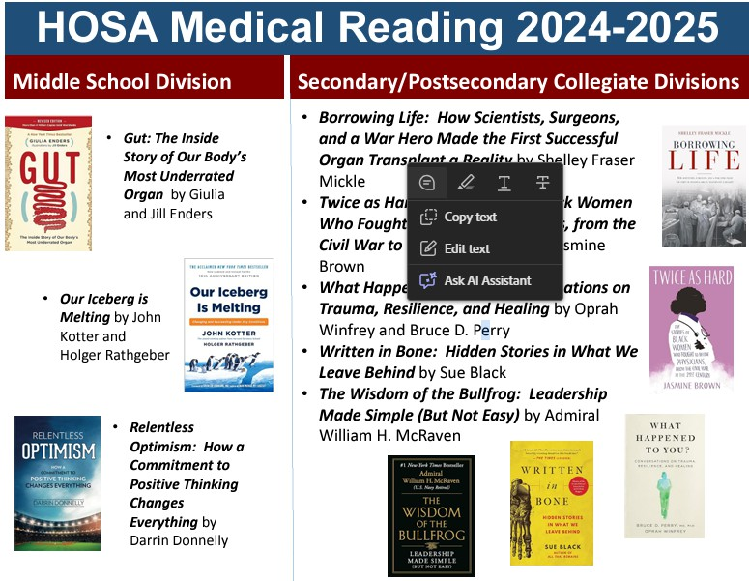

#### 2024 - 2025

Awards and Recognition:

Students will be recognized at the first awards session for top participation in the National Geographic ATC testing and the Health Care Issues exam.

Multiple Event Placements:

With these changes, students can place in the top 5 for more than one event at SLC. If this occurs, they must choose one event to compete in at the International Leadership Conference (ILC).

Page 16

### CHAPTER SUCCESS GUIDE

2024 - 2025

## RECOGNITION EVENTS

HOSA’s Recognition Events are designed to recognize members and chapters for outstanding work in HOSA and HOSA-related projects. Students can choose from six events, with recognition on both the state and national levels.

Although students can only compete in one competitive event at the state and national conferences, they can participate in as many recognition events as they wish.

The Recognition Events are:

* Health Care Issues Exam
* American Red Cross Volunteer
* America’s Blood Center – HOSA Blood Drive
* National Service Project
* Barbara James Service Award
* HOSA Happenings
* Health Literacy Ambassador
* Outstanding HOSA Achievement

Complete rules and guidelines, criteria, applications, and verification forms are available on our website at [http://nevadahosa.org/recognition.](http://nevadahosa.org/recognition)

Page 17

### CHAPTER SUCCESS GUIDE

#### 2024 - 2025

**INTERNATIONAL LEADERSHIP CONFERENCE**

The Annual International Leadership Conference (ILC) brings together thousands of future health professionals from across the country! This conference features:

* Exciting general sessions
* Educational and social learning activities
* Leadership academies
* Tours to healthcare facilities
* Exhibits presented by professional healthcare associations
* National Competitive Events
* Annual business of the national student organization of HOSA, including the election of national leaders
* Educational symposiums
* Fun, excitement, recognition, and opportunities for HOSA members!

Welcome to Tennessee!

This year’s International Leadership Conference will be held June 18-21, 2025, at the Gaylord Opryland Convention Center Nashville, TN. For more information, visit <https://hosa.org/ilc/>.

Eligibility

All members registered by the Nevada HOSA ILC deadline are eligible to attend ILC.

For competitive events, Nevada HOSA sends the top three competitors/teams in each event to compete at ILC. To be eligible to compete, chapters must complete every step in the Registration Process, including the Intent to Compete Form and Online Conference Registration.

ILC Registration Process

Nevada HOSA publishes an ILC Registration Guide each year, which serves as a guide for preparing for ILC. **Although the National HOSA provides registration information and deadlines, it is important to adhere to Nevada HOSA’s process *to be eligible to attend.***

**May 12, 2025, is the Nevada HOSA ILC Registration deadline.** This is three days before National HOSA’s deadline to allow state staff to assist and confirm registration. *If completed after this deadline, NV HOSA Staff will not be able to assist with registration.*

**State Winners List:** Following the State Leadership Conference, Nevada HOSA publishes the list of winners. The top three individuals or teams in each event are eligible to compete at Internationals. However, if a competitor decides not to attend ILC, Nevada HOSA will move up

Page 18

### CHAPTER SUCCESS GUIDE

#### 2024 - 2025

to the next competitor. This means that members placing 4th or 5th could still have an opportunity to compete at nationals.

Intent to Compete: All top five winners in all competitive events must submit an Intent to Compete form. This form serves as official notification to Nevada HOSA regarding a competitor’s

* + Every competitor who received 1st, 2nd, 3rd, 4th, or 5th place MUST complete an Intent to Compete form, even if the competitor(s) will not attend ILC. Any forms not received by the Intent to Compete deadline will be assumed to be a “No, will not attend” response.

Intent to Compete Deadline: March 19, 2025

**ILC Competitor Notification:** All Intent to Compete Forms will be processed, and chapters will be notified with a final ILC Competitor List. This list will be published on the Nevada HOSA website at [www.nevadahosa.org](http://www.nevadahosa.org/).

ILC Competitor Notification Release Date: March 26, 2025

**ILC Online Registration:** The Nevada HOSA ILC Registration Guide will provide the steps to register for the conference. Although National HOSA provides registration information and deadlines, adhering to Nevada HOSA’s process is important.

Chapters are responsible for registering students for events and confirming chapter details. Registration must be completed by the Nevada HOSA deadline, as a validation process takes place immediately after the deadline.

**ILC Registration Payment:** Registration payments should be directed to Nevada HOSA. Please make checks payable to Nevada HOSA and mail

check to:

Nevada HOSA

P. O. Box 1440

Owasso, OK 74055

ILC 2019 Extemporaneous Writing Winners (Right: Rachel Weese, Nevada Bronze Medalist)

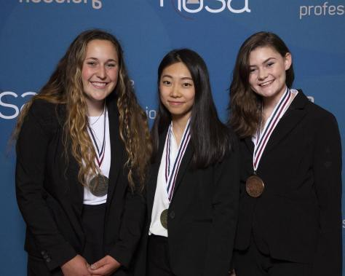

Page 19

### CHAPTER SUCCESS GUIDE

#### 2024 - 2025

**TIP: IT’S NEVER TOO EARLY!**

It’s never too early to start planning for the International Leadership Conference! Start planning by saving the dates in the calendar, studying competitive event guidelines, and fundraising.

Page 20

### CHAPTER SUCCESS GUIDE



2024 - 2025

## STATE PROGRAMS AND OPPORTUNITIES

**Chapter Visits**

Having a state officer visit a local chapter connects state officers with local members while giving the state officers an opportunity to promote state and national conferences, programs, and initiatives. State officers can discuss a particular event, explain HOSA to a new chapter, and encourage students to get involved. Oftentimes chapters can connect with a state officer’s passion, excitement, and commitment to HOSA and use it to foster those same feelings in their chapter. To schedule a visit, go to this link: <https://nevadahosa.org/request-a-chapter-visit/>

**Nevada HOSA Weekly Update**

Check your email for the NVHOSA Weekly Update - If you are not receiving it, please contact [hello@nevadahosa.org](mailto:hello@nevadahosa.org)

**Nevada HOSA Social Media**

Nevada HOSA is on Instagram, where we regularly post quick updates and announcements about events, activities, programs, health-related news and announcements, and key accomplishments. Visit us on Instagram and sign up to follow Nevada HOSA to stay up to date on what’s new and happening with Nevada’s Future Health Professionals!

###### WEBSITES

Nevada HOSA [www.nevadahosa.org](http://www.nevadahosa.org/) National HOSA [www.hosa.org](http://www.hosa.org/)

Nevada Association for Career and Technical Education [www.nacteonline.org](http://www.nacteonline.org/) NDE Office of Career, Technical & Adult Education <https://doe.nv.gov/CTE/>

State Pin Design Contest

Every year Nevada HOSA creates a state pin used as the State Leadership Conference pin and as the official trading pin for the state during the International Leadership Conference. Members are encouraged to create a pin design that captures Nevada, the state/national theme, and/or the ILC destination. Voting will take place at the Leadership Experience and the winning pin design will be used as the inspiration for the official trading pin of Nevada. Click the link below for more information.

Page 21

### CHAPTER SUCCESS GUIDE

#### 2024 - 2025

<https://nevadahosa.org/documents/>

**Questions? Please contact:** [Stateadvisor@nevadahosa.org](mailto:Stateadvisor@nevadahosa.org) | (888) 677-4534

Page 22

### CHAPTER SUCCESS GUIDE

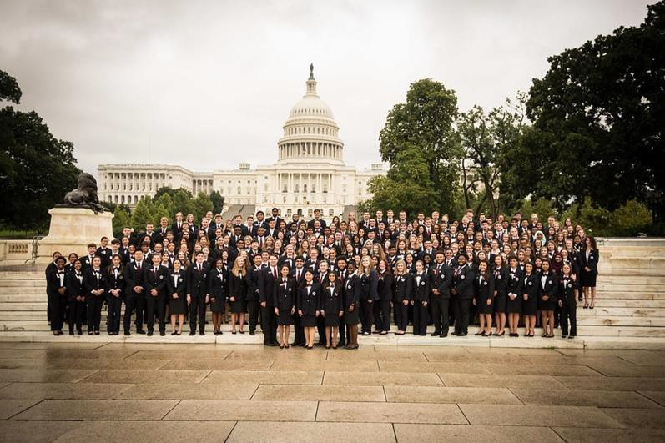

2024 - 2025

## NATIONAL PROGRAMS AND OPPORTUNITIES

Washington Leadership Academy

The Washington Leadership Academy in Washington, D.C., has been hosted annually by HOSA for State Officers and Local Chapter Leaders. It is a training experience for future HOSA leaders who are interested in learning more about running for local chapter office, becoming a more effective leader, understanding and valuing people, interacting with others, and serving the organization and others. This action-packed experience provides the highest level of HOSA leadership training available. We encourage local chapter leaders and members who want to strengthen their leadership skills and build their resume to join HOSA in Washington, D.C. There are also opportunities for local chapter advisors to interact and share valuable ideas with other HOSA advisors. The Washington Leadership Academy will be hosted September 27-30, 2024. For more information, visit [www.hosa.org](http://www.hosa.org/).

Page 23

### CHAPTER SUCCESS GUIDE

#### 2024 - 2025

HOSA E-Magazine

The HOSA E-Magazine is the official publication of National HOSA for its members, advisors, partners, and supporters. The E-Magazine includes articles and information on chapter spotlights, alumni success stories, HOSA partners, healthcare related news, HOSA conferences, events and opportunities, and more! Many of the articles are written by individual members and every chapter is encouraged to write and submit an article. The E-Magazine is published three times a year and articles can be sent to [hosa@hosa.org](mailto:hosa@hosa.org) at any time for inclusion in the next issue. Visit [www.hosa.org](http://www.hosa.org/) and select “E-Magazine” on the left menu bar to view the latest E-Magazine!

## SCHOLARSHIPS

HOSA’s inter-curricular program fosters a culture of learning, discovery, and hard work. HOSA members look to prepare for their futures, and many continue their education into the postsecondary/collegiate level. HOSA’s scholarship program is designed to support members’ pursuit of a higher education and reward outstanding members with scholarships. Visit the website below for further information.

<https://hosa.org/scholarships/>

## ALUMNI

Any supporters of HOSA are encouraged to become Alumni members! How to become an alumni member:

* Complimentary alumni membership is available at both the state and national level. It’s free!!!
* Go to <https://apps.hosa.org/#alumni-registration> and apply for Alumni Membership
* Complete the application and submit to National HOSA. That’s all you need to do!
* Registration is one time only; you don’t have to do it again!

Page 24

HOSA DRESS CODE POLICY

Delegates are required to wear either the Official Uniform, or the Suit Option to all General Sessions.

**OFFICIAL UNIFORM**

* + Tailored navy blazer with emblem affixed over the heart
  + Matching navy slacks or navy knee-length skirt
  + White, closed-neck, tailored dress shirt suitable for tie or scarf
  + Accents: maroon HOSA scarf or maroon or navy long tie
  + Closed-toe blue or black shoes (hose optional for women)
  + Belt (blue or black)
  + Head covers that are required for religious purposes or to honor cultural tradition are allowed

##### General Sessions

**SUIT OPTION**

* + - Black or navy-blue suit
    - White, closed-neck, tailored dress shirt (maroon or navy long tie)
    - White blouse (can be member"s choice)
    - Accent: maroon HOSA scarf (optional)
    - Members may choose to wear knee-length skirt or slacks
    - Closed-toe blue or black shoes (hose optional for women)
    - Belt (blue or black)
    - Head covers that are required for religious purposes or to honor cultural tradition are allowed

If the competitive event guidelines identify business attire is appropriate, any of the following dress is acceptable (color is not specified for clothing or shoes for competition):

(closed·toe: open-toe: heeled)

Delegates must adhere to the policy as specified in the individual competitive event guidelines for the orientation and event in which they are competing.

If the competitive event guidelines identify clinical uniform or attire appropriate to the occupational area for skill events, the following dress is acceptable (scrubs can be of any color/design, with or without a HOSA emblem):

**Official**

**HOSA Uniform**

,:,

**Business Attire**

* Shirts • Jackets
* Skirts • Sports Jackets
* Dresses • Pants



Medical Scrubs

* + Scrubs
  + Clinical shoes or tennis shoes



Polo & Khakis

* + - Khaki pants with polo top

HEALTH PROFESSIONS EVENTS

Event Specific Dress Code

*.*

HEALTH SCIENCE EVENTS II EMERGENCY PREPAREDNESS EVENTS II

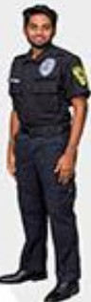*Examples of htollh professions appropriate attire ore pictured below,*

LEADERSHIP EVENTS II TEAMWORK EVENTS II RECOGNITION II NATIONAL GEOGRAPHIC LEARNING ACADEMIC TESTINGCENTER

Competitors must be in official HOSA uniform or in proper business attire. *Bonus points will be awarded for proper dress.*

EXTEMPORANEOUS HEALTH POSTER

Competitors must be in official HOSA uniform, proper business attire, medical scrubs, or polo and khakis. *Bonus points wi1/ be awarded for proper dress.*

**CERT**

SKILLS

EMT SPORTS

MEDICINE

FORENSIC MEDICINE

Competitors shall wear the HOSA uniform, proper business attire, medical scrubs, or polo and khakis.

*Bonus points will be awarded in both rounds for proper dress. All team members must be properly dressed to receive bonus points.*

Competitors shall wear proper business attire or official HOSA uniform, or attire appropriate to the occupational area, during the orientation, written test and skill(s) -Jeans and shorts are not acceptable. *Bonus points will be awarded for proper dress.*

**f** hosa.org future health professionals